F-54 -

Functionality
Clearing down payment allows you to post a clearing document manually. This function is similar to transfer posting. You clear a down payment (posted with special GL transaction) and another vendor document (e.g. vendor invoice).

Scenario
A vendor asked to be paid a down payment before the delivery. The down payment was made and posted. Now you need to clear the down payment with a vendor invoice.

Requirements
Outstanding vendor down payment and vendor document (e.g. invoice).

Menu Path | Accounting → Financial Accounting → Accounts Payable → Document Entry → Down Payment → Down Payment Clearing
Transaction Code | F-54

1. Double click on F-54 - Down Payment Clearing

Clear Vendor Down Payment: Header Data

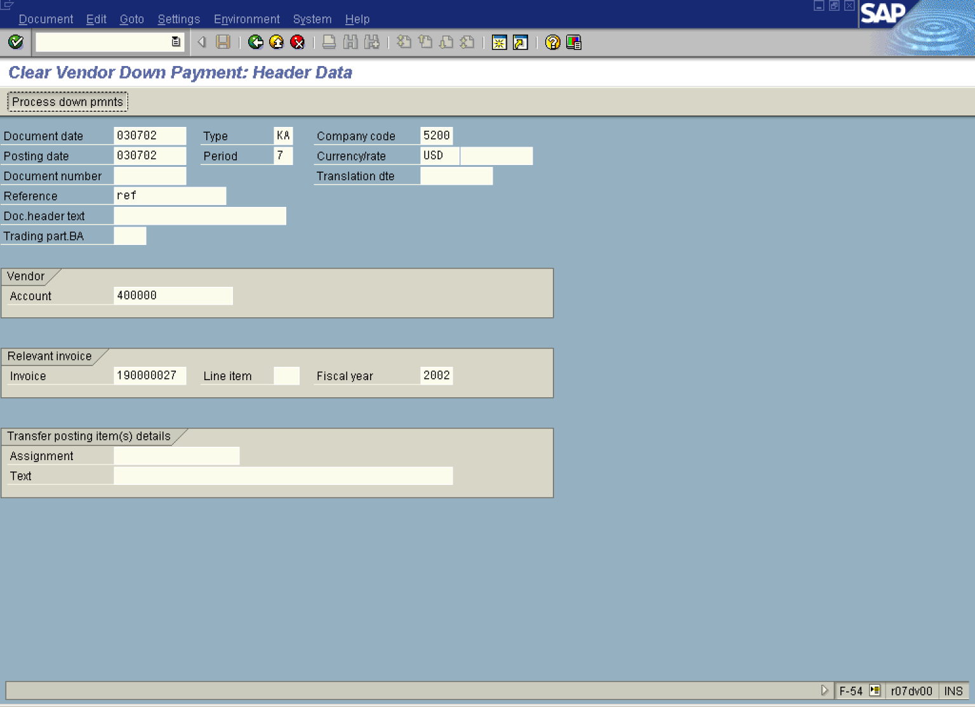

2. Update the following fields:

Field Name | Field Description | Values
Document date | Date the transaction occurred | Example: 030702
Type | Type of accounting document | Example: KA
Company code | Code identifying a separate legal entity for which a separate set of accounts is maintained for external reporting purposes | Example: 5200
Posting date | Date that the business transaction occurred | Example: 030702
Currency/rate | Code identifying the currency used in the transaction | Example: USD
Reference | Additional document description | Example: ref
Account | Code identifying the Vendor account | Example: 400000
Invoice | Enter here an invoice number you want clear a down payment with | Example: 190000027
Fiscal year | Fiscal year number | Example: 2002

Tip: If you don’t know the vendor invoice number, you can open another SAP session (Press Create New Session button) and display the vendor open items – transaction code FBL1N.

3. Click Process down pmnts Button to process down payments.

Clear Vendor Down Payment: Choose down payments

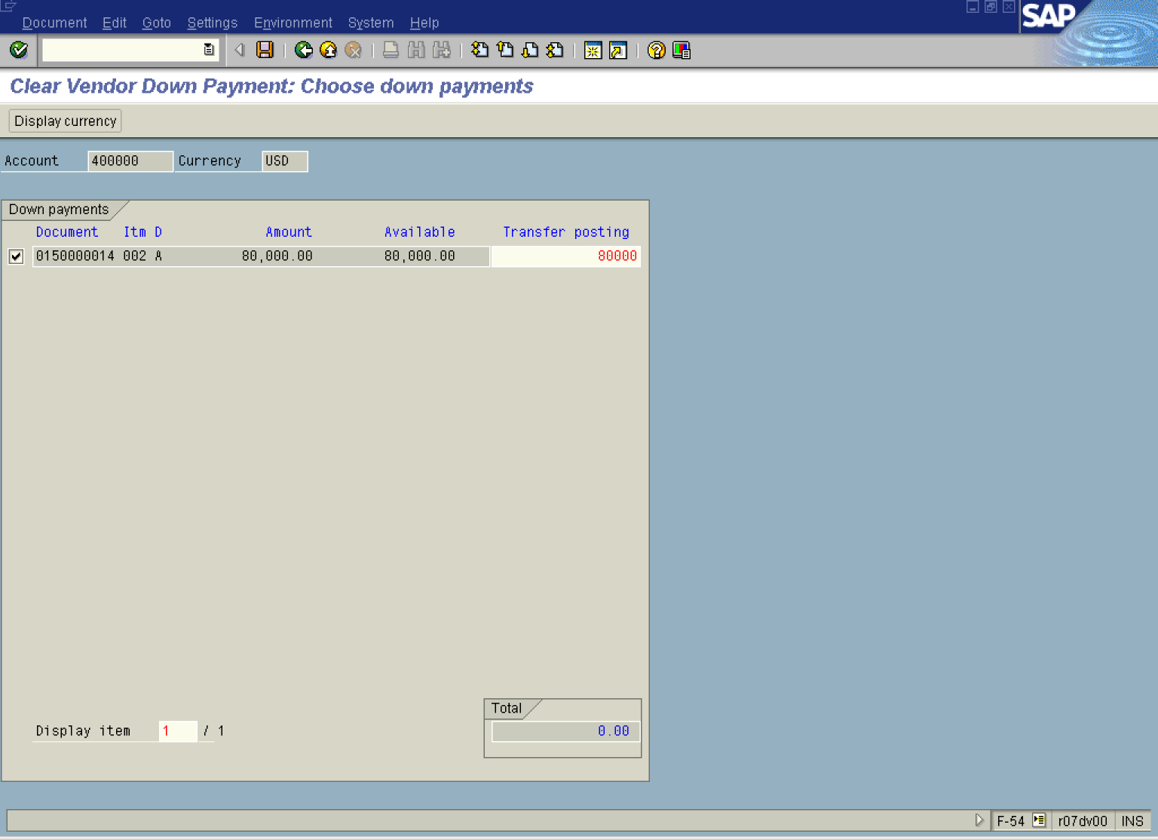

4. The system has displayed a list of outstanding down payments. Click <checkbox> to mark the down payments you want to process.

5. Click Enter Button to confirm your entries. The system will enter an amount of 80.000,- USD in the field “Transfer posting”.

6. Click Save Button to post a clearing document. The system will display a document overview:

Clear Vendor Down Payment: Display Overview

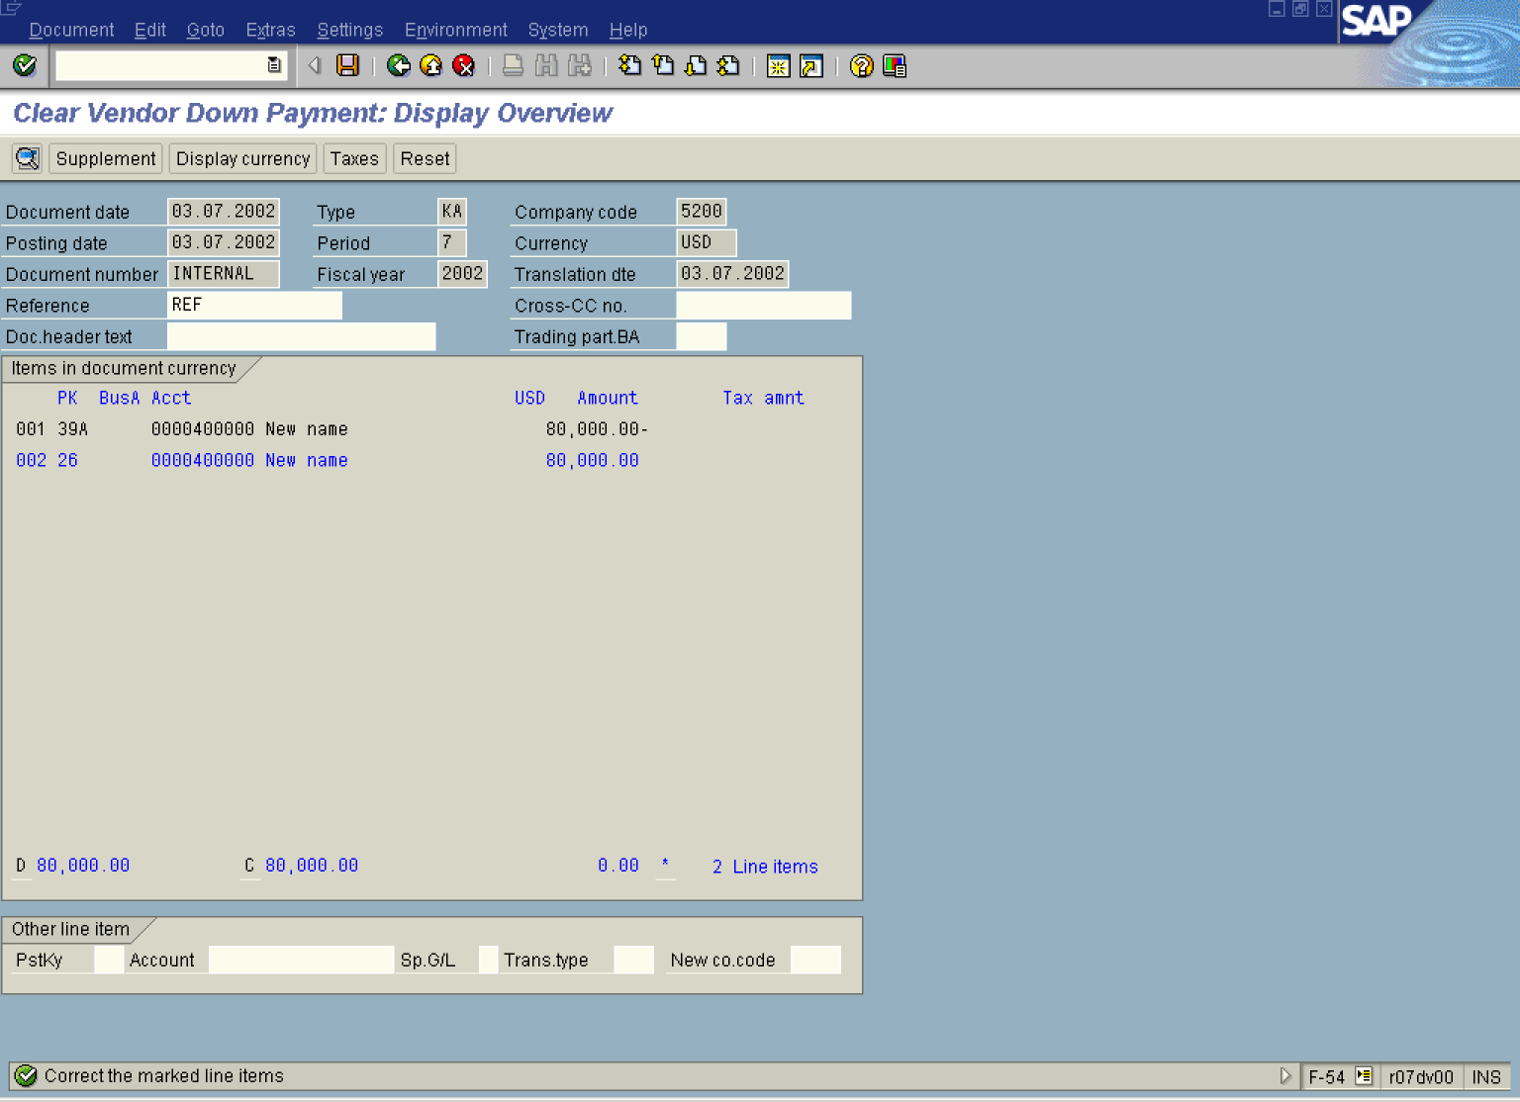

7. The line item 002 is highlighted in blue. Some additional data must be entered. Double click on this line:

Clear Vendor Down Payment: Correct Vendor item

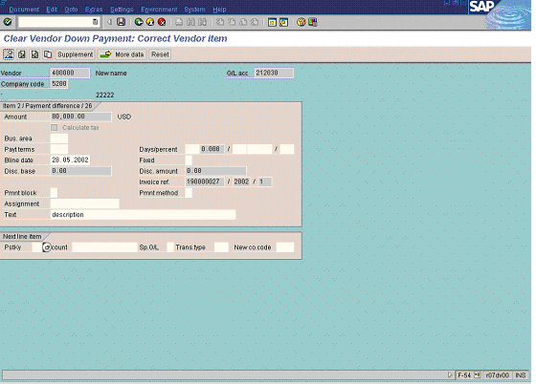

8. Update the following fields:

Field Name | Field Description | Values
Text | Document description | Example: description

9. Click Save..

Clear Vendor Down Payment: Display Overview

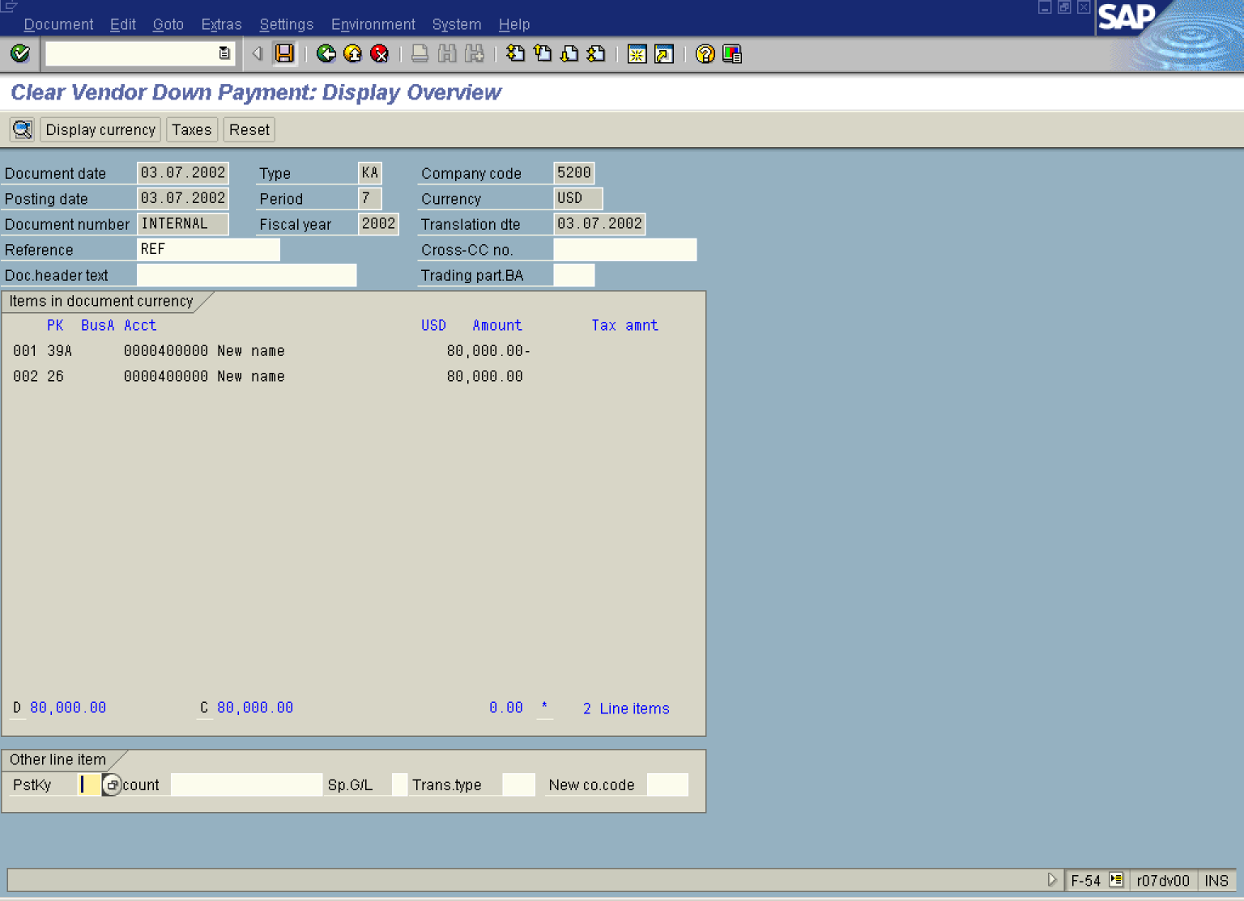

10. The message bar displays “Document XXXXXX was posted in company code 5200”

 This transaction only transfers the down payment amount from Special GL account the the main reconciliation account. Further it also links the down payment posting to the invoice.
11. Display vendor open items (FBL1N). As you can see, the newly posted clearing document is still outstanding and you need to clear it with the invoice using the account clearing process (Transaction f-44).

